**UNIVERSIDAD AUTONOMA DE COAHUILA**

**CENTRO DE IDIOMAS UNIDAD PIEDRAS NEGRAS**

**LINK IT 1B**

**LEVEL 2**

**1ST EXAM**

**STUDENT’S NAME: ____________________________________ DATE: ________________**

**TEACHER’S NAME: ____________________________________**

**PART I. VOCABULARY (15 points)**

Look at the pictures. Complete the labels.

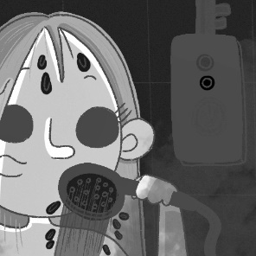 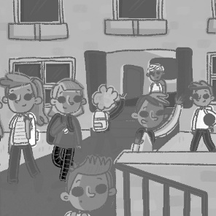

**1** t _ _ e a s _ _ w_ r **2** f _ _ _ _ h sc _ _ _ l

**3** h _ _ e l _ _ _ h **4** g _ t h _ _ e

**5** _ _ v _ br _ _ _ fa _ t **6** w _ _ _ h T

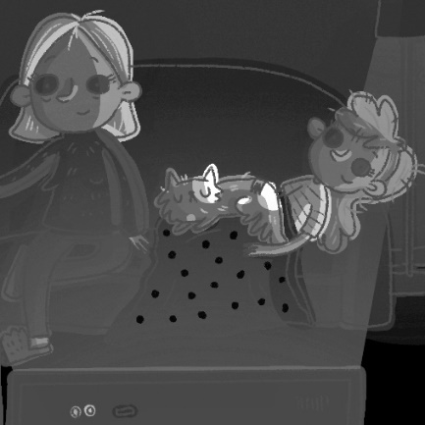 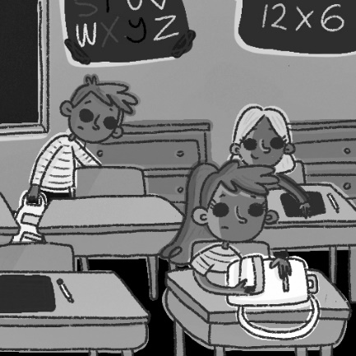

**7** g_ t _p **8** S_ _ r_ S_ _ oo_

Complete the dialogues with the words in   
the box.

|  |
| --- |
| busy want do idea watch instead let’s |

Colin What do you 1__________ to do?

Hannah 2__________ go to the store.

Colin No, let’s go to the park 3__________.

Maddie 4__________ you want to play *Minecraft*?

William OK, that’s a good 5__________.

Sophia Let’s 6__________ a movie.

Martin No, I’m sorry, but I’m 7__________.

**PART II. GRAMMAR (15 points)**

Complete the sentences with the correct form of the verbs in parentheses.

**1** I __________ (make) pizza every weekend.

**2** He __________ (sing) at school.

**3** My parents often __________ (listen) to music.

**4** My grandpa __________ (speak) French and Japanese.

**5** Ella __________ (play) the guitar.

**6** We __________ (practice) soccer every day.

**Reorder the words to make sentences.**

**1** in the morning / we / TV / watch / never .

______________________________________

**2** sometimes / to the park / go / my parents .

______________________________________

**3** am / always / I / after school / hungry .

______________________________________

**4** often / my sister / on Fridays / tennis / plays .

______________________________________

**5** late / they / rarely / are .

______________________________________

**6** on the weekend / usually / play video games / my friends .

______________________________________

Complete the sentences with the negative (🗶) form of the verbs in parentheses.

**1** Mark ________________ (come) from the U.S.

**2** I ________________ (live) in New York City.

**3** Ellie and Leo ________________ (study) French.

**PART III. LISTENING (5 points)**

T03 Listen to the radio interview. Choose the correct alternatives.

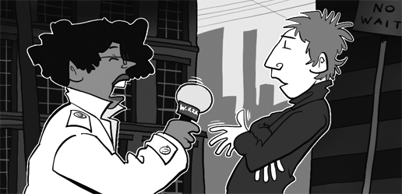

**1** On weekends, Marcus gets up at ___ o’clock.

**a** seven **b** ten **c** eleven **d** twelve

**2** Marcus ___ takes his bike to school.

**a** always **b** sometimes **c** usually **d** never

**3** Marcus does his homework ___.

**a** every day **b** at home **c** on Fridays **d** at school

**4** Marcus has band practice ___.

**a** on Mondays **b** every day **c** on Saturdays   
**d** once a week

**5** On the weekend, Marcus visits his ___.

**a** friends **b** grandma **c** aunt **d** cousins

**PART IV. READING (5 points) points)COMPREHENSION**

Read the blog. Then do the exercises.

**Food in Texas**

*How often do you eat in restaurants? What dishes do you love? Do you know how to cook them? This week’s food blog is by Clara West from Corpus Christi, Texas.*

Corpus Christi is a great place to try Texan food—especially fish dishes—because it’s next to the ocean. There are some great restaurants, but my favorite restaurant is my grandparents’ restaurant, The Catch. I often go there after school, and my grandpa teaches me how to cook regional dishes.

Tacos with meat are popular in Texas, but here in Corpus Christi we love fish tacos. Tourists love them, too. They’re white fish in corn tortillas with yogurt, vegetables, Mexican cheese, and special flavorings. Perfect! My favorite dish is Shrimp Picayune. It’s shrimp with lemon juice and brown sugar. It’s fantastic with rice and salad. I have it once a week.

Of course, Texans love meat. Chicken Fried Steak is a famous Texan dish. But it doesn’t have any chicken in it! It’s beef (red meat) fried in egg and flour. People usually eat it with potatoes and vegetables.

On the weekend, my friends and I often have lunch in town. We don’t usually sit in restaurants. We buy sandwiches, pizzas, or tacos. My favorite lunch is a hamburger and fries from a great restaurant called Lulu’s. We sometimes have a float. It’s soda with ice cream in it.

Sundays are great. My parents and I never get up early on Sundays. We sometimes walk to the Yellow Bird Restaurant for a late breakfast. They make a big English breakfast, and we love it! In summer, we have a barbecue by the ocean about once a month. Dad cooks and we sit by the ocean, eat awesome food, and chill out!

Answer the questions.

**1** What is “The Catch”?

______________________________________

**2** When does Clara go to The Catch?

______________________________________

**3** How often does Clara eat Shrimp Picayune?

______________________________________

**4** What do people eat with chicken fried steak?

______________________________________

**5** When do Clara and her family go to the Yellow Bird Restaurant?

______________________________________

**PART V. WRITING (10 points)**

Use the information in the fact file to write a paragraph about a popular food in China.

|  |
| --- |
| **A popular food in China:** fried rice  **Ingredients:** rice, eggs, vegetables  **How often do people eat it?** every day 🗶 often ✓  **When do people eat it?**  lunch ✓ dinner ✓ breakfast 🗶  **Where do people eat it?** at home  **What do people eat it with?** meat (sometimes), fish (sometimes) |

Fried rice is a popular food ___________________

_________________________________________

_________________________________________

_________________________________________

_________________________________________

_________________________________________

_________________________________________

_________________________________________

_________________________________________

_________________________________________